Task 2-
Level 0 → 1 I knew the password was sitting right inside the readme file in the home directory. I simply used the cat readme command to print the contents of the file to my terminal and grabbed the flag.
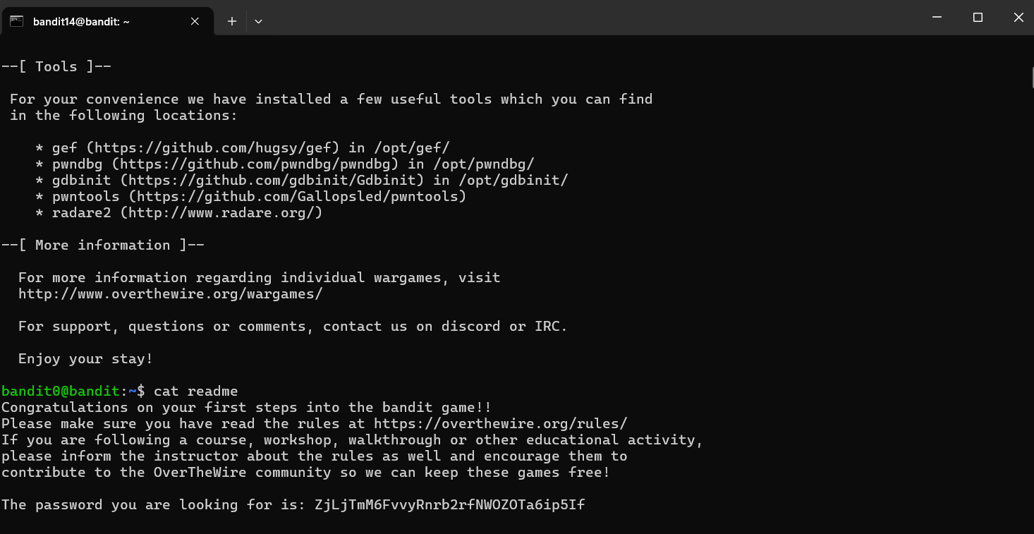
Level 1 → 2 The file containing the password was just named -, which confused the cat command because it thought it was a command-line flag. I realized I had to specify the relative path to the file, so I used cat ./- to force the terminal to read it as a file.
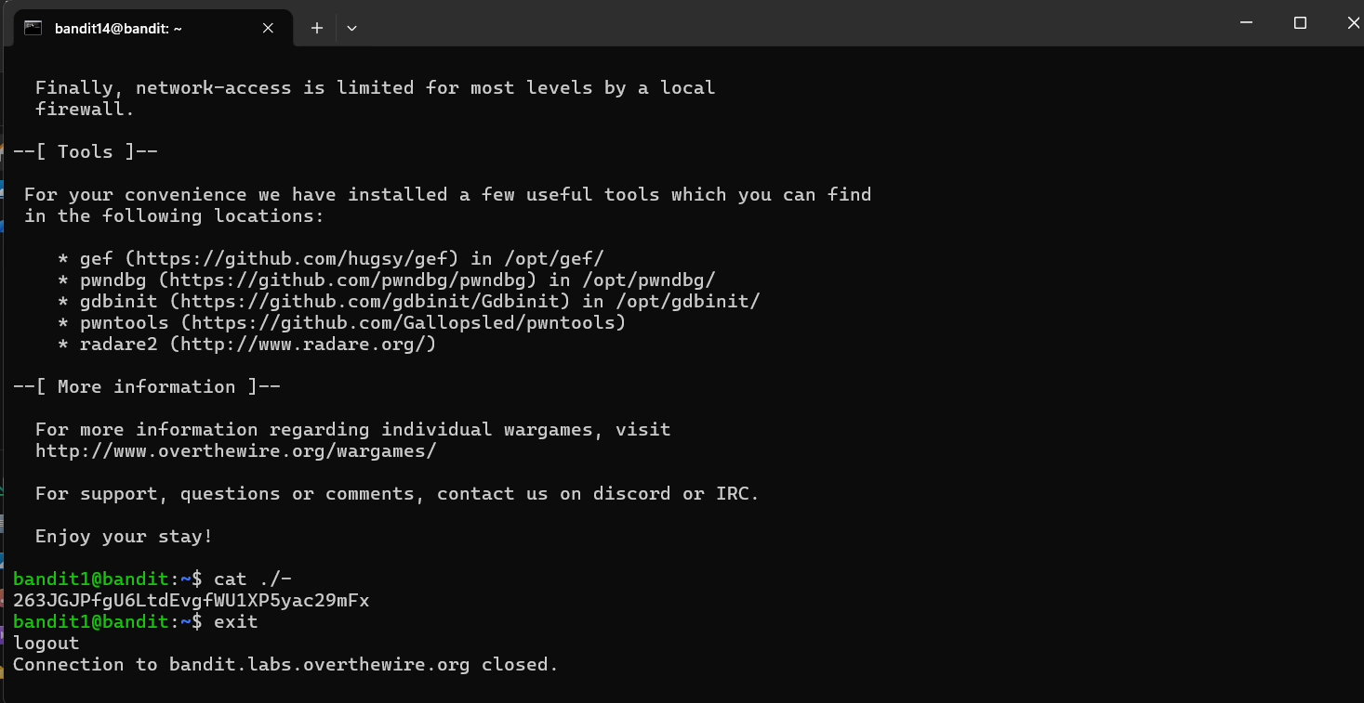
Level 2 → 3 The filename had spaces in it ("spaces in this filename"). To prevent the terminal from misinterpreting the spaces and trying to read four separate nonexistent files, I wrapped the filename in quotes and ran cat "spaces in this filename".
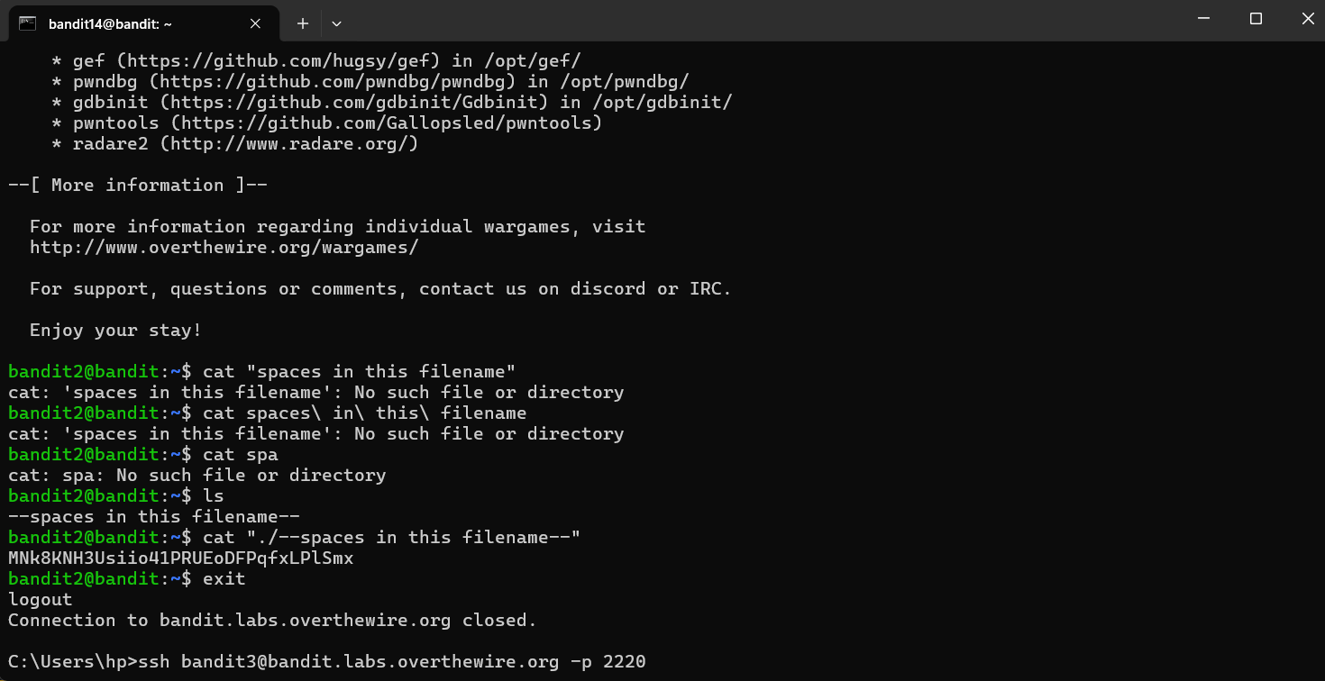
Level 3 → 4 When I cd into the inhere directory, typing ls showed it was completely empty. I remembered that Linux hides files that start with a dot, so I used ls -a to reveal the .hidden file and then read it with cat.
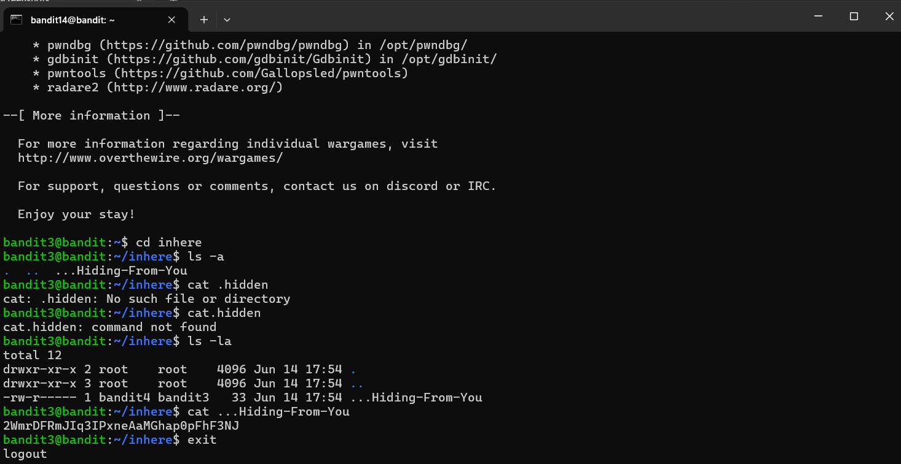
Level 4 → 5 There were multiple files starting with -file, and trying to read them all was messy since most were gibberish. I needed to find the one human-readable file, so I used the file ./* command to check all their types and spotted the only one labeled as "ASCII text."
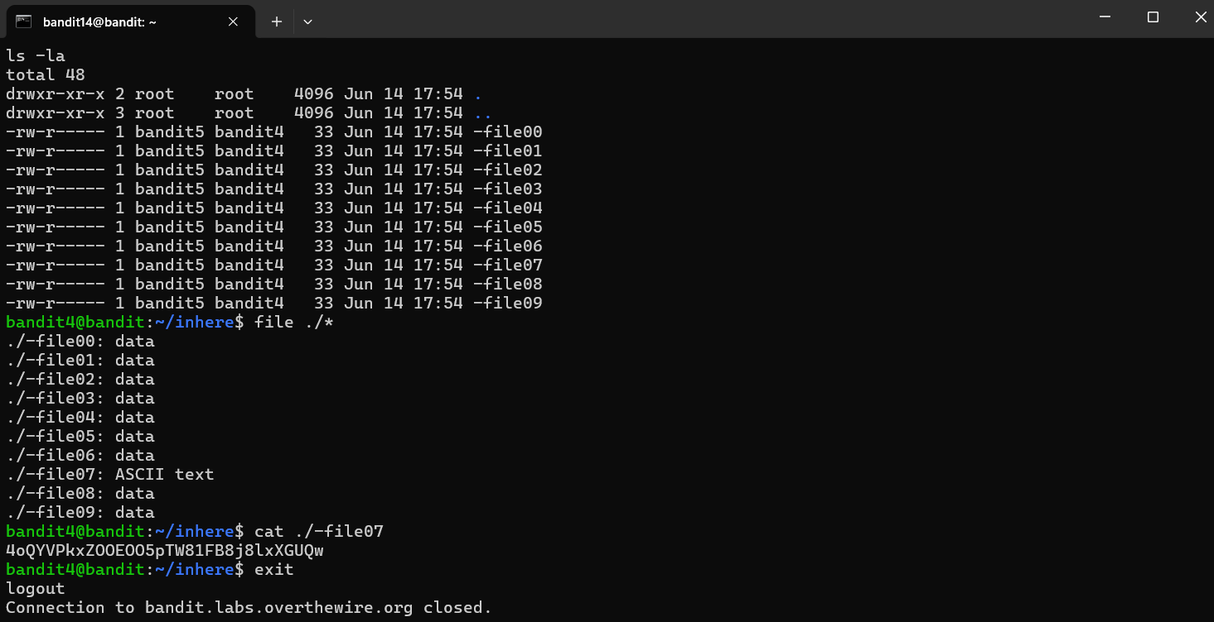
Level 5 → 6 The password was hidden deep in a maze of directories, but I knew its exact properties: 1033 bytes and not executable. Instead of looking manually, I used the find command with the parameters -size 1033c and ! -executable to make the server pinpoint the exact file for me.
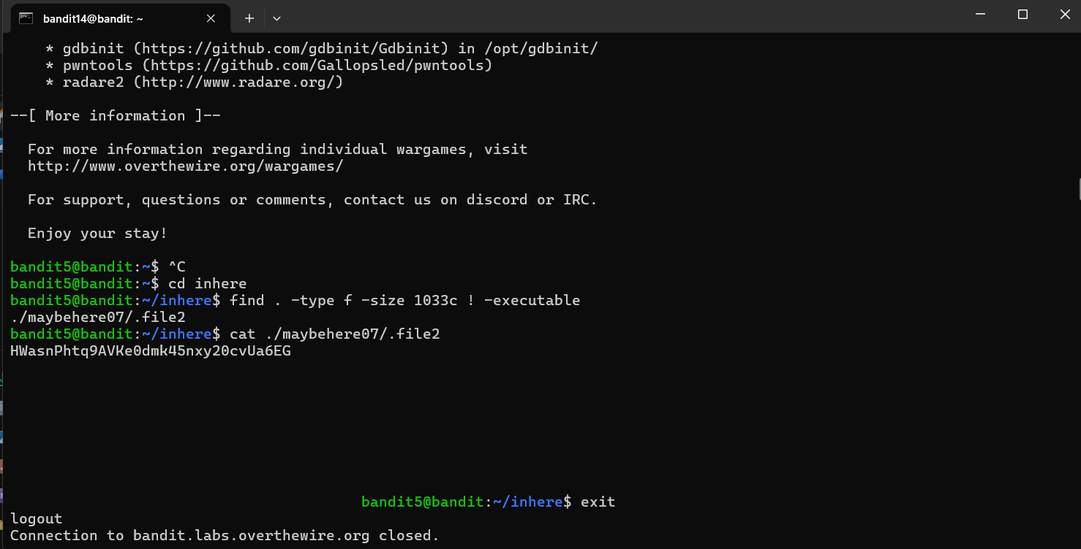
Level 6 → 7 This level required searching the entire server (/), which immediately flooded my screen with "Permission denied" errors. I ran the find command with the specific user and group ownerships, but I added 2>/dev/null to the end of my command to throw away the errors so I could actually see the correct file path.
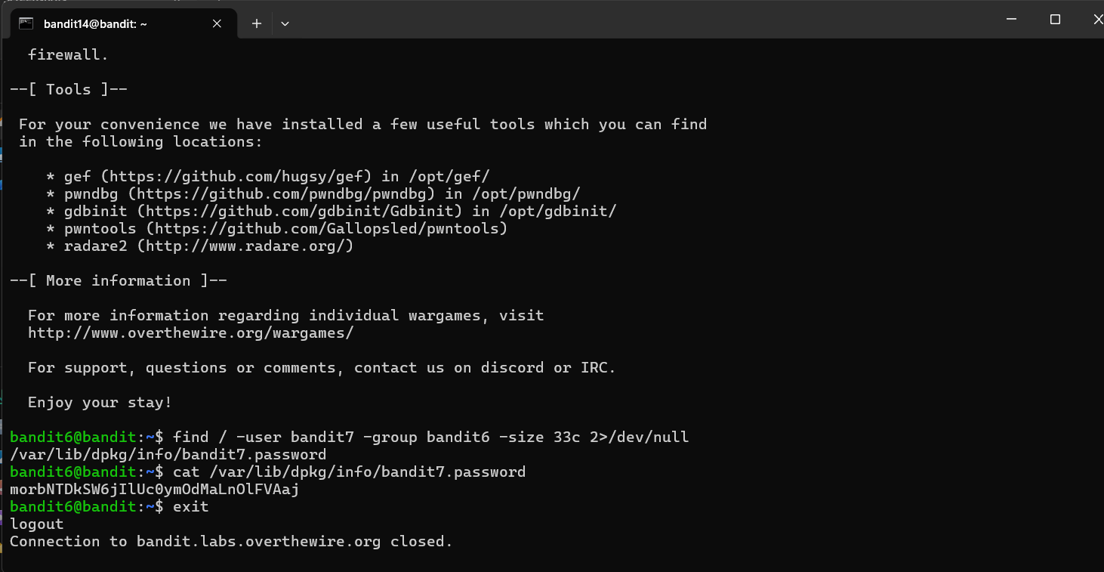
Level 7 → 8 The password was buried in a massive data.txt file right next to the word "millionth." Manually scrolling was impossible, so I used grep "millionth" data.txt to search the file and instantly filter out the exact line I needed.
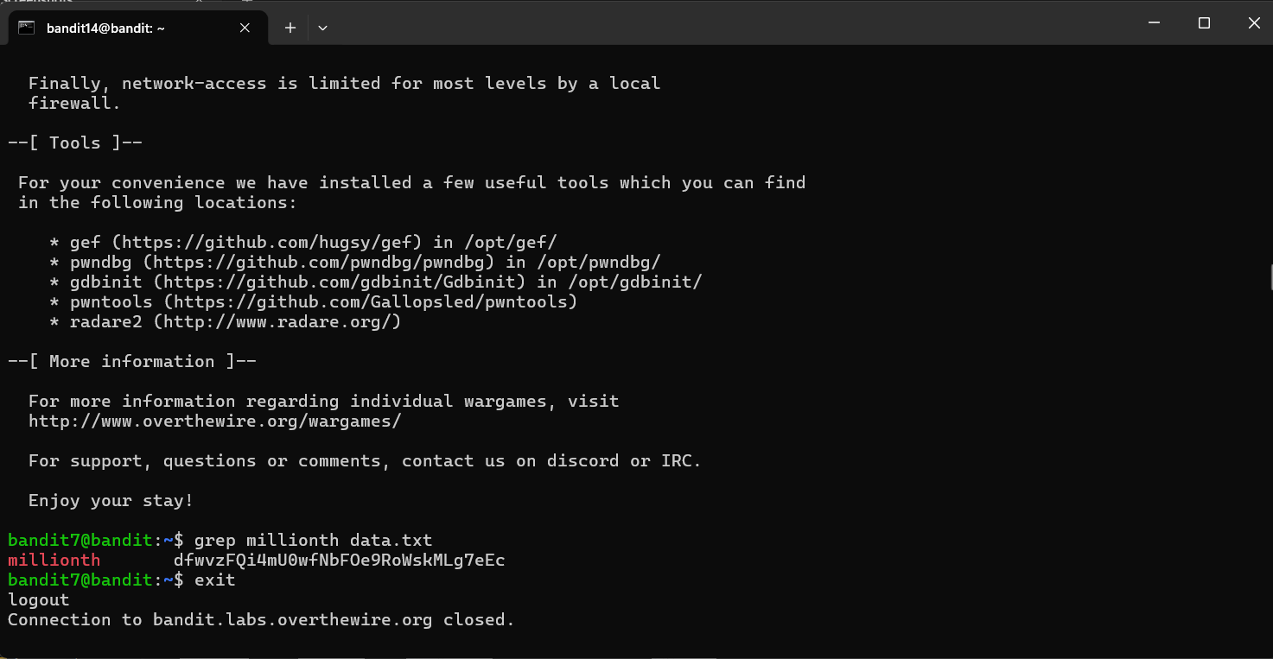
Level 8 → 9 I needed to find the only non-repeated line in a file. I realized the uniq command only checks adjacent lines, so I couldn't use it right away; I had to pipe the file into sort first to group the duplicates, and then pipe that into uniq -u to single out the password.
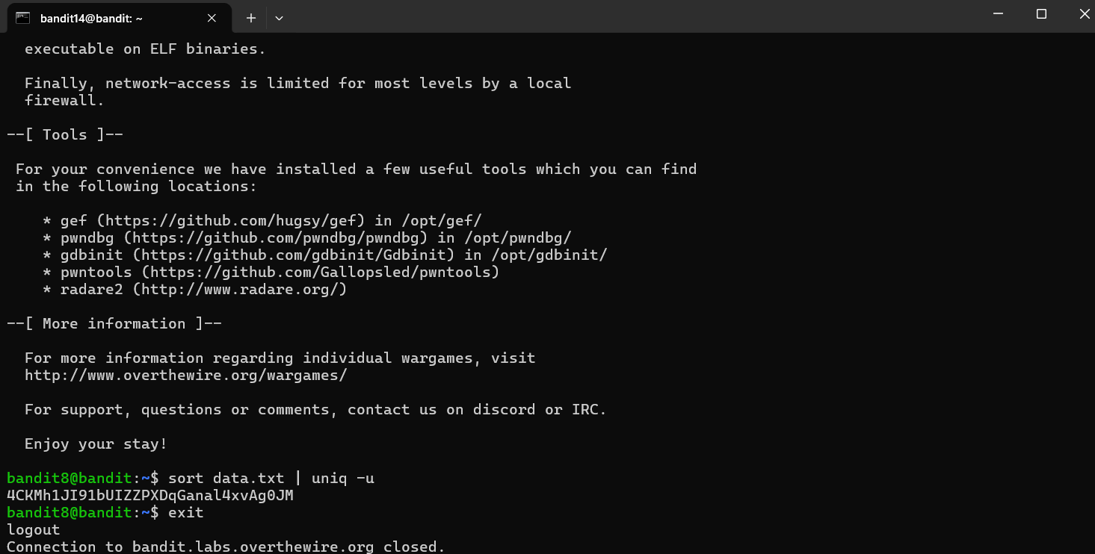
Level 9 → 10 The file was mostly binary gibberish, and using cat on it completely broke my terminal output. I used the strings command to extract only the human-readable text from the binary file, and then piped it to grep "=" to find the password.
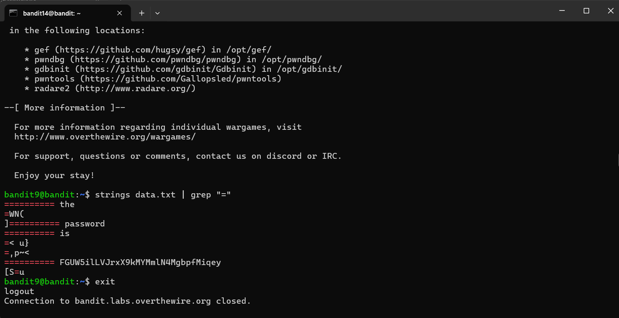
Level 10 → 11 The data looked like a random block of letters and numbers ending in equal signs, which is a dead giveaway for base64 encoding. I just ran base64 -d data.txt to decode it back into plain text.
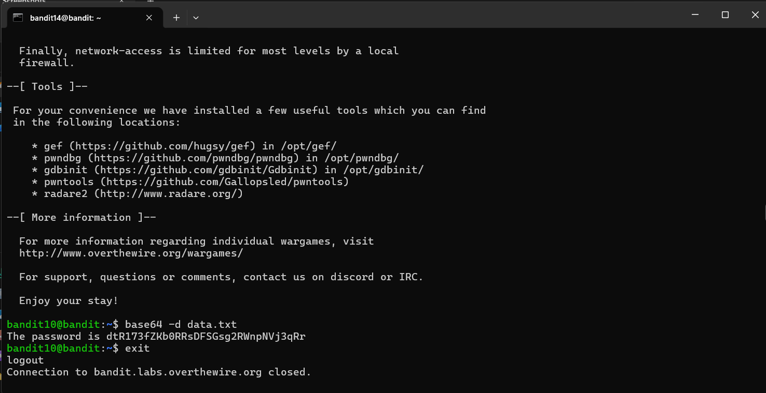
Level 11 → 12 The text was scrambled, but the prompt hinted it was shifted by 13 characters (a standard ROT13 cipher). I used the tr command to map the alphabet and translate it back by shifting every letter 13 spots: tr 'A-Za-z' 'N-ZA-Mn-za-m' < data.txt.
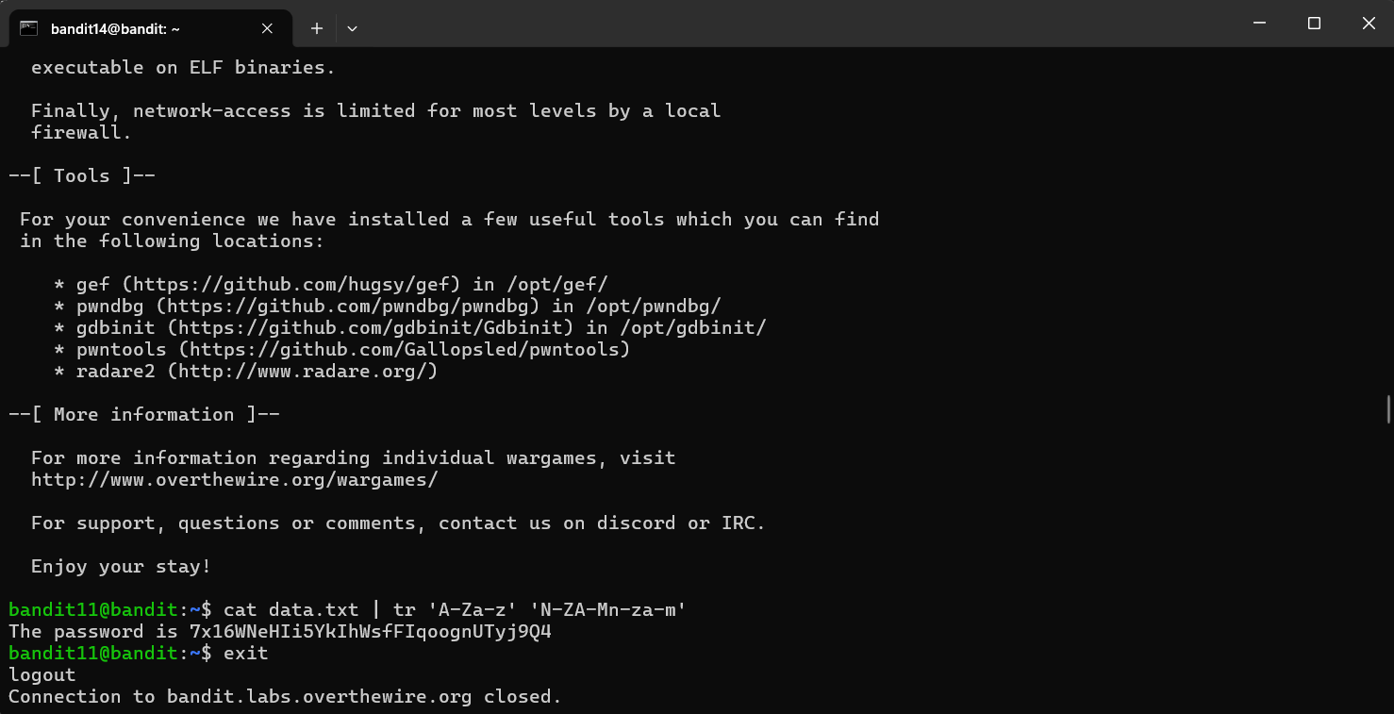
Level 12 → 13 This was a tedious nesting doll of compressed files. I first had to reverse a hexdump using xxd -r, and then I repeatedly used the file command to figure out if I needed to peel back the next layer with tar, gzip, or bzip2 until I finally hit plain text.
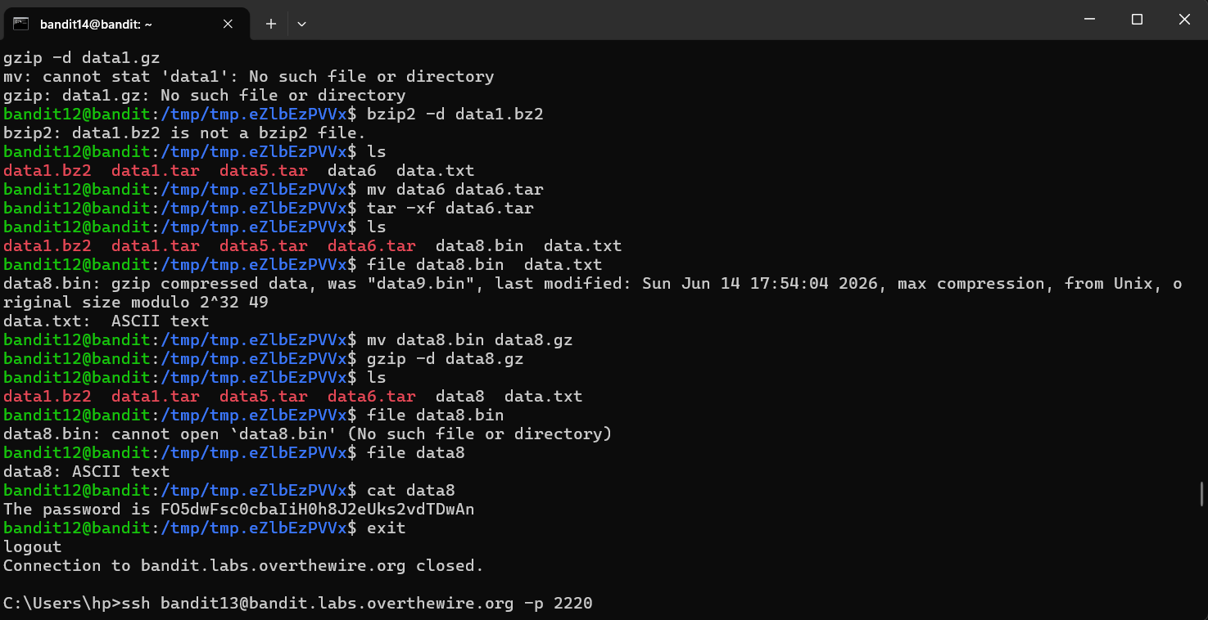
Level 13 → 14 Instead of a standard password, this level gave me an SSH private key (sshkey.private). I had to use this file as my identity badge, running ssh -i sshkey.private bandit14@localhost -p 2220 to authenticate directly into the next level without a password.
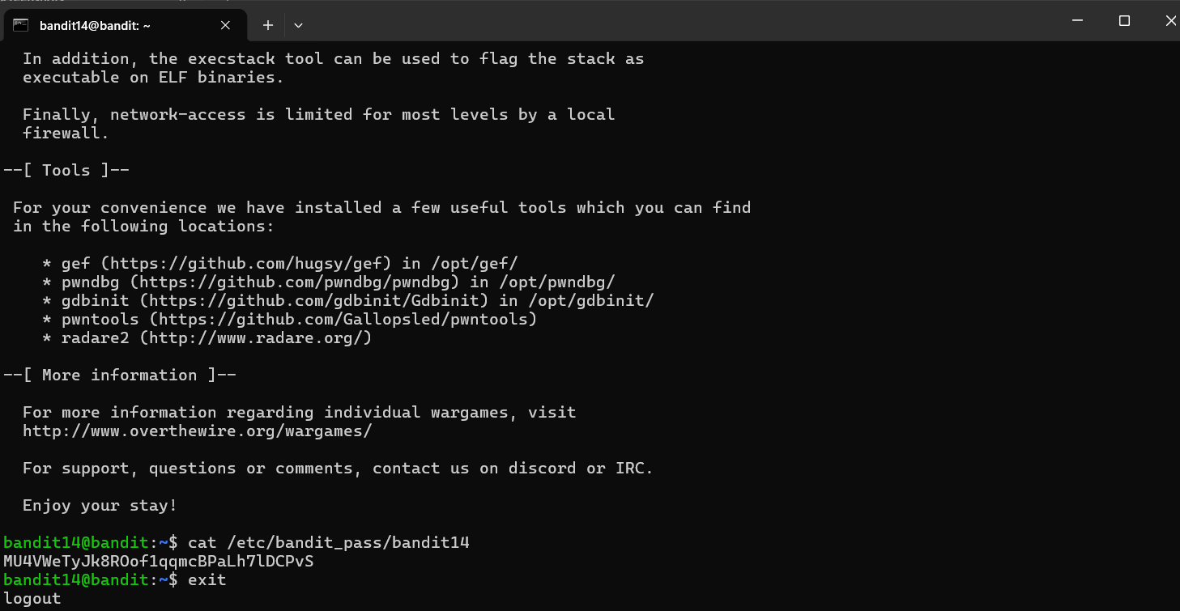
Level 14 → 15 I needed to send my current Level 14 password to a program listening on port 30000. I used Netcat (nc localhost 30000) to open a direct connection to that port, pasted my password into the prompt, and the server replied with the Level 15 password.
